BPMN Modelling Approach and Thought Process Documentation

Introduction
This document explains the design approach, modelling conventions, and decision-making process used when creating the BPMN diagram representing the external maintenance lifecycle between ProBuild Supplies Ltd and FixPro Ltd. The objective of the model was to visually represent operational responsibilities, inter-organisational communication, and task execution methods using BPMN 2.0 standards.
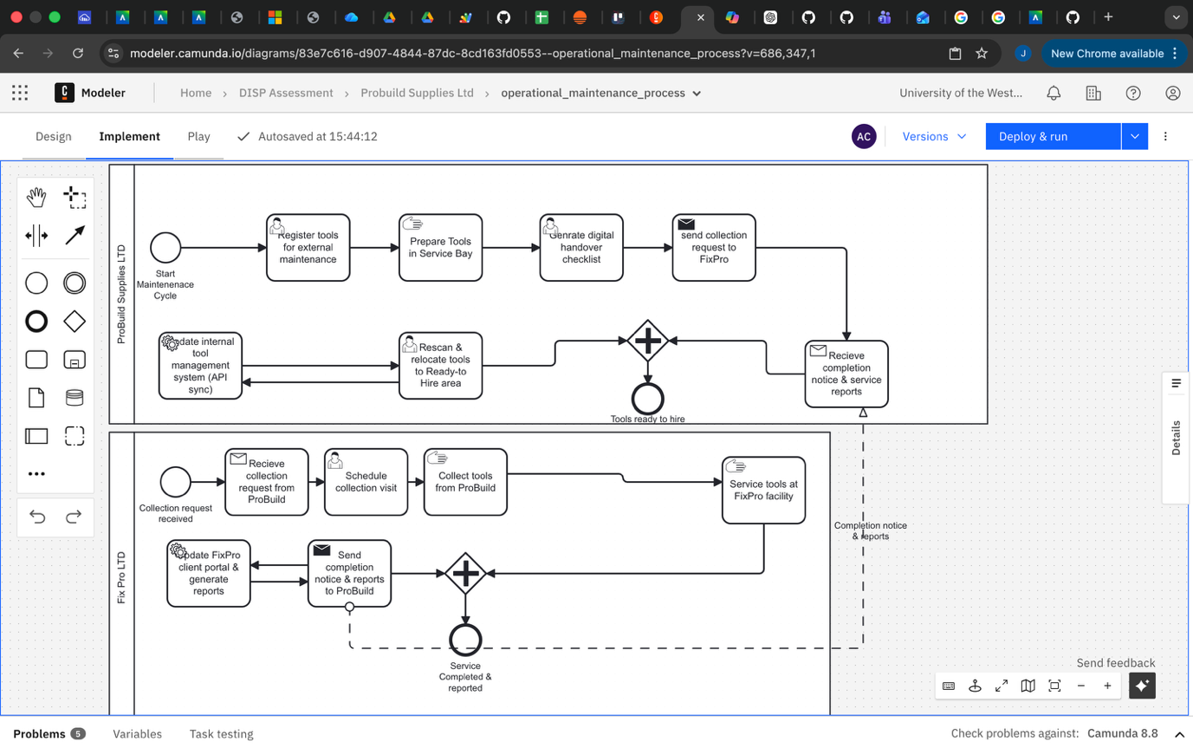

BPMN Modelling Methodology
The model was created using a structured modelling approach consisting of the following stages:
Stage | Description
Process Understanding | Analysed the case study to identify workflow and responsibilities
Stakeholder Identification | Determined organisations and roles involved
Process Decomposition | Broke workflow into sequential tasks
Task Classification | Assigned BPMN task types based on execution method
Visual Standardisation | Applied BPMN notation rules and naming conventions
Process Validation | Verified business logic and communication flows

Organisational Structure Design
Pools were used to represent independent organisations involved in the process:
Pool | Purpose
ProBuild Supplies Ltd | Tool owner and maintenance request initiator
FixPro Ltd | External servicing and repair provider
Sequence flows were used to represent activities performed within each organisation, while message flows were used to represent communication between ProBuild and FixPro.

Task Box Creation and BPMN Activity Selection
Each rectangular text box in the diagram represents a BPMN Activity. The type of activity was determined based on how the work is performed.

Task Type Classification
BPMN Task Type | When It Is Used | Diagram Examples
User Task | Human activity performed through a system or application | Register tools for external maintenance, Generate digital checklist, Schedule collection visit, Rescan tools
Manual Task | Physical activity performed without system interaction | Prepare tools in Service Bay, Collect tools from ProBuild, Service tools at FixPro facility
Send Task | Represents outgoing communication to external party | Send collection request to FixPro, Send completion notice and service reports
Receive Task | Represents incoming communication or data reception | Receive collection request, Receive completion notice and service reports
Service Task | Automated system-driven task without human involvement | Update internal tool management system (API sync)

Reasoning Behind Task Selection
Activity | Selected Task Type | Justification
Register tools for maintenance | User Task | Requires system input and data logging
Prepare tools in Service Bay | Manual Task | Physical preparation work
Generate digital handover checklist | User Task | Created through system interface
Send collection request | Send Task | Represents external communication
Receive completion reports | Receive Task | Represents incoming external communication
Update internal management system | Service Task | Automated API integration

Naming Convention Used
All tasks were named using the Verb + Object format to ensure clarity and BPMN best practice compliance.
Naming Rule | Purpose | Example
Verb + Object | Clearly describes action and outcome | Register Tools
Avoid Technical Jargon | Improves stakeholder readability | Prepare Tools
Use Active Voice | Enhances clarity | Generate Checklist

Event Usage
Events were used to indicate triggers, milestones, and process completion.
Event Type | Purpose | Example
Start Event | Indicates process trigger | Maintenance Cycle Initiated
Intermediate Event | Represents key milestone or status change | Tools Ready to Hire, Service Completed & Reported
End Event | Indicates completion of process responsibilities | Maintenance Cycle Completed

Communication Flow Design
Communication between organisations was modelled using message flows, while internal operations used sequence flows.
Flow Type | Purpose | Example
Sequence Flow | Controls task order within same organisation | Register Tools → Prepare Tools → Generate Checklist
Message Flow | Represents communication between organisations | Send Collection Request → Receive Collection Request
Milestone Events | Represents process status checkpoints | Tools Ready to Hire

Process Logic Considerations
The process was structured to reflect the real-world maintenance lifecycle.
Process Phase | Key Activities
Preparation | Tools registered, prepared, and documented
Handover | Tools transferred to FixPro with checklist verification
Servicing | Inspection, maintenance, repair, and compliance testing
Reporting | Service reports generated and shared
Reintegration | Tools re-scanned and returned to hire availability

BPMN Compliance and Design Justification
The model follows BPMN 2.0 standards by applying correct modelling constructs.
BPMN Principle | Implementation
Organisational Separation | Pools used for ProBuild and FixPro
Correct Task Classification | Task types selected based on execution method
Controlled Communication | Message flows used only between organisations
Clear Task Naming | Verb + Object format applied consistently
Process Readability | Milestones represented using intermediate events

Conclusion
The BPMN diagram was designed to accurately represent the external maintenance lifecycle while maintaining readability and professional modelling standards. Task classifications were selected based on execution method, ensuring clear differentiation between system-driven tasks, manual operational activities, and communication-based interactions. The final model provides a structured and standardised visual representation of the maintenance workflow between ProBuild Supplies Ltd and FixPro Ltd.

